Week 4
Examination of a website to test the vulnerability of attacks. – DVWA setup & SQLi.
Input:-
Clone the DVWA repository from GitHub.
sudo git clone https://github.com/digininja/DVWA.git

Program:-

Step 1: Navigate to the Web Root Directory
Open the terminal and move to the Apache web server directory.
Command:
cd /var/www/html
Verify the contents of the directory.
ls

Step 2: Download the DVWA Application
Verify that the project has been downloaded.
ls
Rename the folder.
sudo mv DVWA dvwa
Provide the necessary permissions.
sudo chmod -R 777 dvwa

Step 3: Configure DVWA
Move to the DVWA configuration directory.
cd dvwa
ls
cd config
Check the available files.
ls
Copy the configuration template.
sudo cp config.inc.php.dist config.inc.php
Edit the configuration file.
sudo nano config.inc.php
Modify the following database settings:
$_DVWA['db_server'] = '127.0.0.1';
$_DVWA['db_database'] = 'dvwa';
$_DVWA['db_user'] = 'admin';
$_DVWA['db_password'] = 'password';
Save the file.
Verify the configuration.
sudo cat config.inc.php

Step 4: Start the Database Server
Start the MySQL service.
sudo service mysql start
Login as the root user.
sudo mysql -u root -p
Create the DVWA database.
Create database dvwa;
Create a database user.
Create user admin@localhost identified by 'password';
Grant privileges.
grant all on dvwa.* to admin@localhost;
/*Apply the changes.
FLUSH PRIVILEGES;*/
Exit MySQL.
exit;

Step 5: Configure PHP
Navigate to the PHP configuration directory.
cd /etc/php/8.4/apache2
ls
Open the PHP configuration file.
sudo nano php.ini
Modify the required PHP settings (allow_ul_include=ON), save the file, and exit.

Step 6: Start Apache and MySQL Services
Start the Apache web server.
sudo service apache2 start
Ensure that the database service is running.
sudo service mysql start

Step 7: Open DVWA in the Browser
Open a web browser and enter:
http://localhost/dvwa
Login using the default credentials:
- Username: admin
- Password: password
Click Create/Reset Database.

Step 8: Configure the Security Level
- Login to DVWA.
- Select DVWA Security.
- Change the security level to Low.
- Click Submit.

Step 9: Open the SQL Injection Module
- From the DVWA menu, click SQL Injection.
- Observe the input field requesting a User ID.
Enter a valid User ID:
1
Click Submit.
1’OR’1’=’1’#
Observation:
The application displays the corresponding user information from the database.

Result
The DVWA web application was successfully installed and configured on the local Apache server. Students learned how to set up a vulnerable web application, configure a MySQL database, and examine the behavior of the SQL Injection module in a controlled laboratory environment. The experiment helped students understand the causes of SQL Injection vulnerabilities and the importance of implementing secure coding techniques to protect web applications.
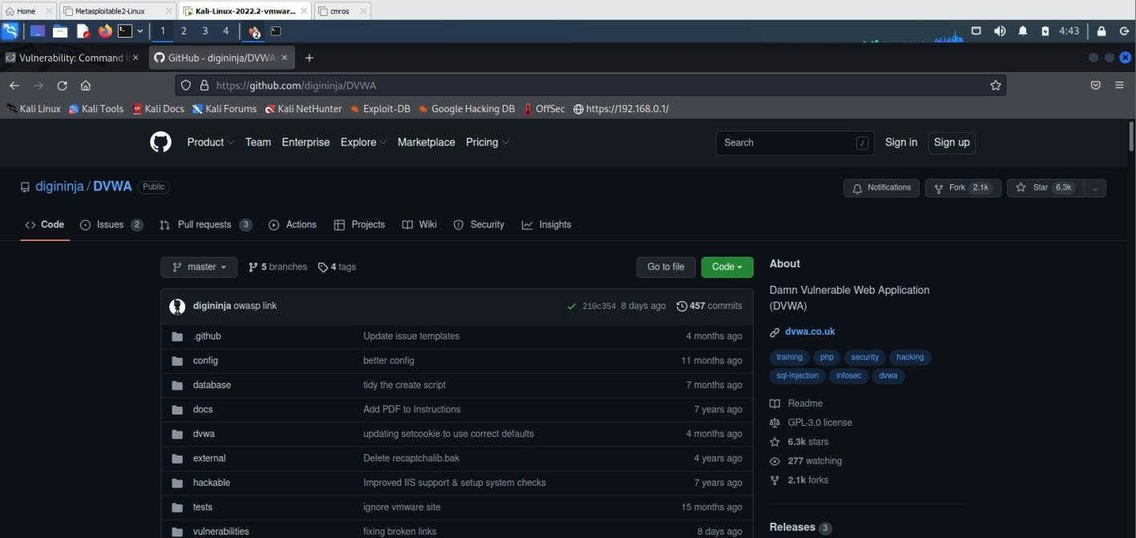
Output:-
